Name: Anmol Srivastava
Course: Devops Tutedude
Subject: Linux Commands Assignment
Date: 18/07/2026

1. Creating and Renaming Files/Directories

Task 1.1: Create a Directory
Command:
mkdir test_dir

Explanation:
The mkdir (Make Directory) command is used to create a new directory in Linux. In this task, a directory named test_dir is created in the current working directory. Directories help organize files and folders efficiently within the Linux file system.
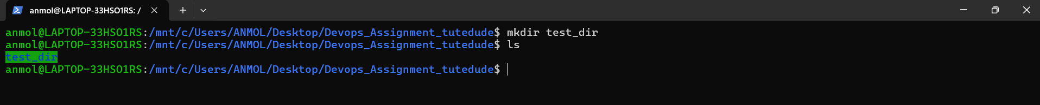

Task 1.2: Create an Empty File
Command:
cd test_dir
touch example.txt
Explanation:
The cd command changes the current working directory to test_dir, allowing operations to be performed inside it. The touch command creates an empty file named example.txt. If the file already exists, touch updates its last modified timestamp instead of creating a new file.
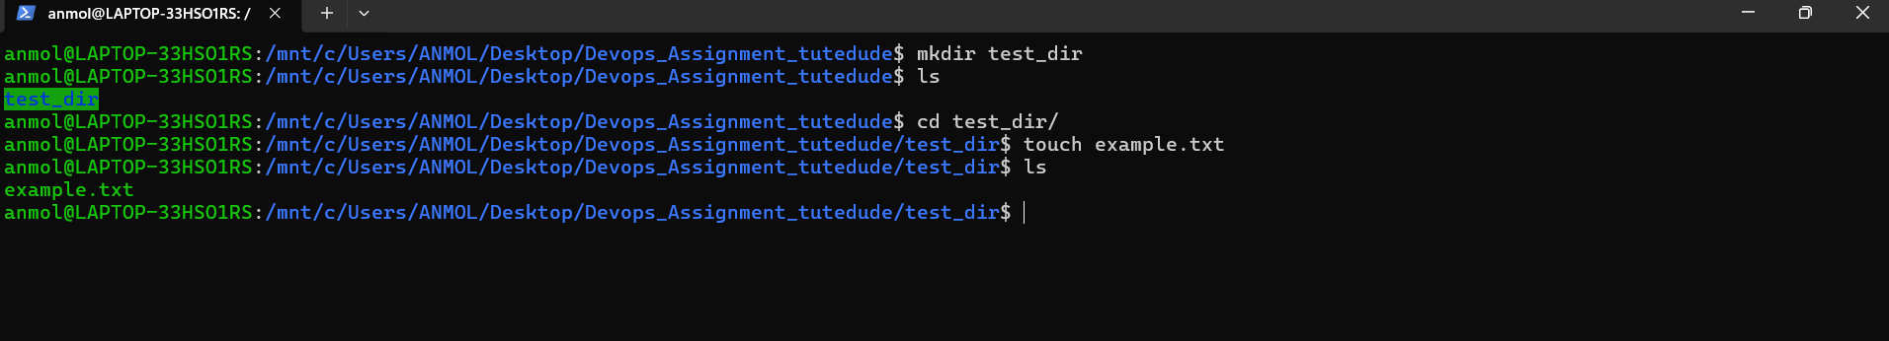

Task 1.3: Rename the File
Command:
mv example.txt renamed_example.txt
Explanation:
The mv (Move) command is used to rename or move files and directories. In this task, the file example.txt is renamed to renamed_example.txt while remaining in the same directory.
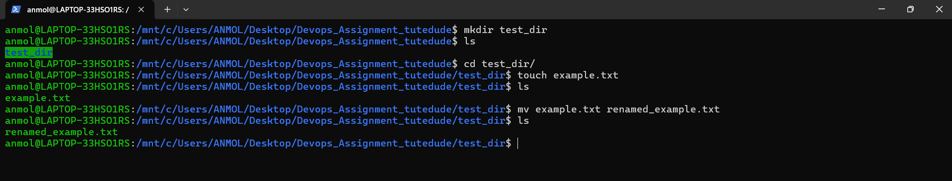

2. Viewing File Contents

Task 2.1: Display Complete File Contents
Command:
cat /etc/passwd
Explanation:
The cat command displays the complete contents of a file. The /etc/passwd file is a Linux system file that stores information about user accounts such as usernames, user IDs (UID), group IDs (GID), home directories, and default login shells. It does not store user passwords. Modern Linux systems store password hashes separately in the /etc/shadow file for security.
NOTE - All these three task 2.1, 2.2 , 2.3 (Screenshot is in same image only)
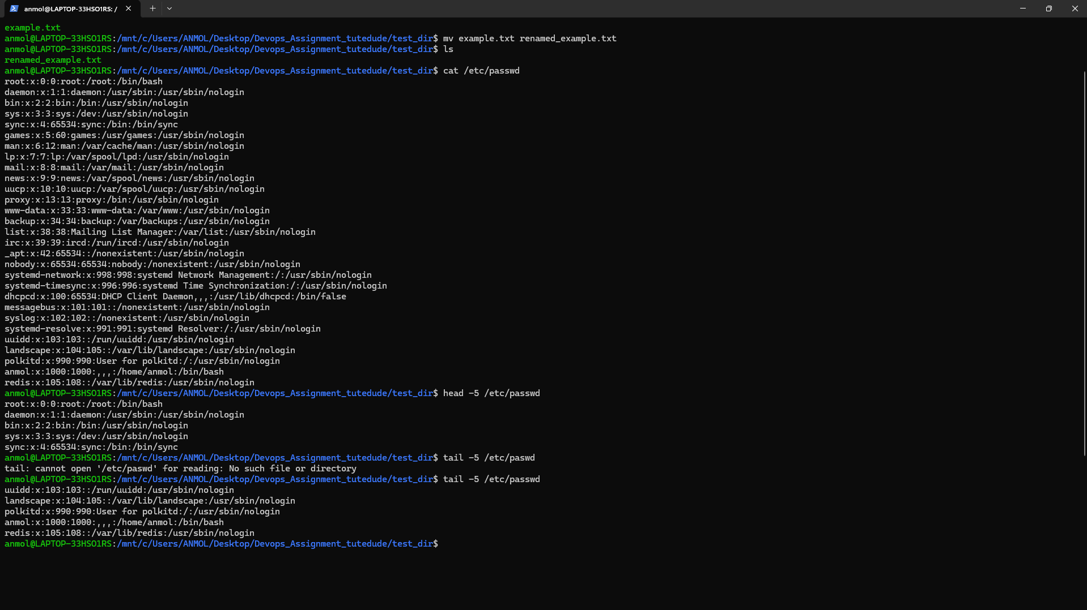

Task 2.2: Display the First Five Lines
Command:
head -5 /etc/passwd
Explanation:
The head command displays the beginning of a file. Using the -5 option instructs Linux to display only the first five lines of the /etc/passwd file. This command is useful when working with large files and only the initial portion is required.

Task 2.3: Display the Last Five Lines
Command:
tail -5 /etc/passwd
Explanation:
The tail command displays the last part of a file. The -5 option limits the output to the final five lines of the /etc/passwd file. This command is commonly used to examine the most recent entries in log files or configuration files.

3. Searching for Patterns

Task 3.1: Search for a Specific Word
Command:
grep "root" /etc/passwd
Explanation:
The grep command searches for a specific pattern or keyword within a file. In this task, it searches for all lines containing the word root in the /etc/passwd file and displays the matching results. It is one of the most commonly used commands for searching text in Linux.

4. Zipping and Unzipping Files

Task 4.1: Compress the Directory
Command:
cd ..
zip -r test_dir.zip test_dir
Explanation:
The zip command is used to compress files and directories into a ZIP archive. The -r (recursive) option ensures that all files and subdirectories inside test_dir are included in the compressed file named test_dir.zip.

Task 4.2: Create a Destination Directory
Command:
mkdir unzipped_dir
Explanation:
This command creates a new directory named unzipped_dir. It will be used as the destination where the compressed ZIP archive will be extracted.

Task 4.3: Extract the ZIP Archive
Command:
unzip test_dir.zip -d unzipped_dir
Explanation:
The unzip command extracts the contents of a ZIP archive. The -d option specifies the destination directory. In this task, the contents of test_dir.zip are extracted into unzipped_dir.
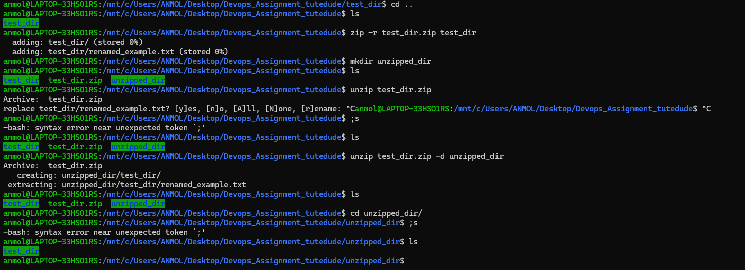
NOTE - All these three task 4.1, 4.2 , 4.3 (Screenshot is in same image only)

5. Downloading Files

Task 5.1: Download a File
Command:
wget https://www.gnu.org/licenses/gpl-3.0.txt
Explanation:
The wget command downloads files directly from the internet using a URL. In this task, it downloads the GNU General Public License version 3 text file and saves it in the current working directory.

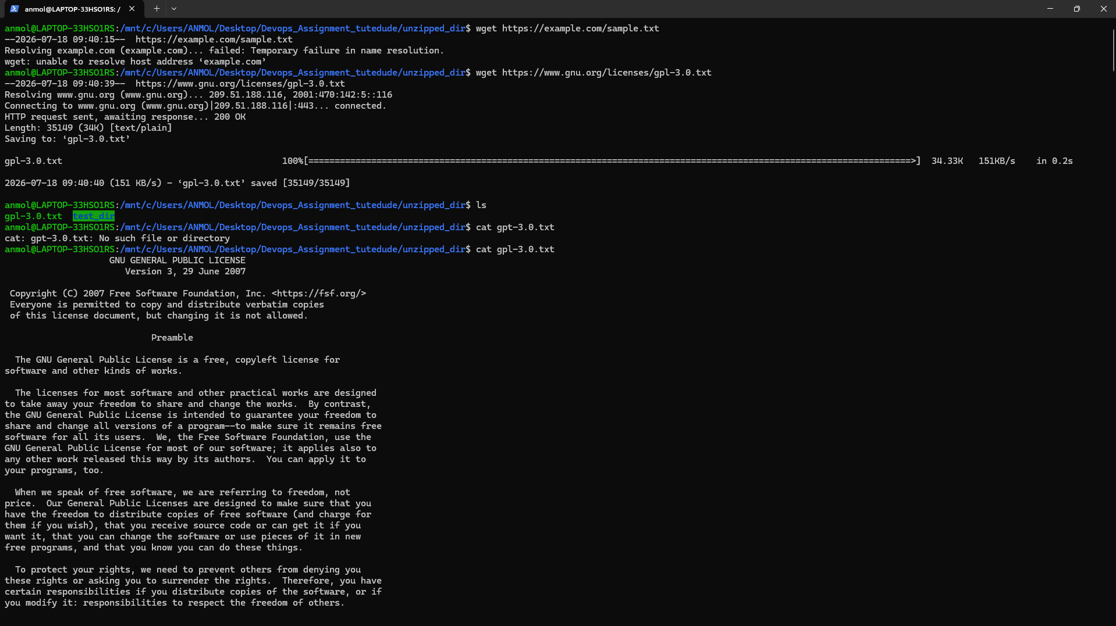

6. Changing File Permissions

Task 6.1: Create a File
Command:
touch secure.txt
Explanation:
The touch command creates an empty file named secure.txt, which will be used to demonstrate file permission management.

Task 6.2: Change File Permissions
Command:
chmod 444 secure.txt
Explanation:
The chmod command changes file permissions. The permission value 444 gives read-only access to the owner, group, and all other users. This means no user can modify or execute the file.

Task 6.3: Verify File Permissions
Command:
ls -l secure.txt
Explanation:
The ls -l command displays detailed information about a file, including its permissions, owner, group, file size, and modification date. After applying permission 444, the expected permission string is:
-r-xr-xr-x
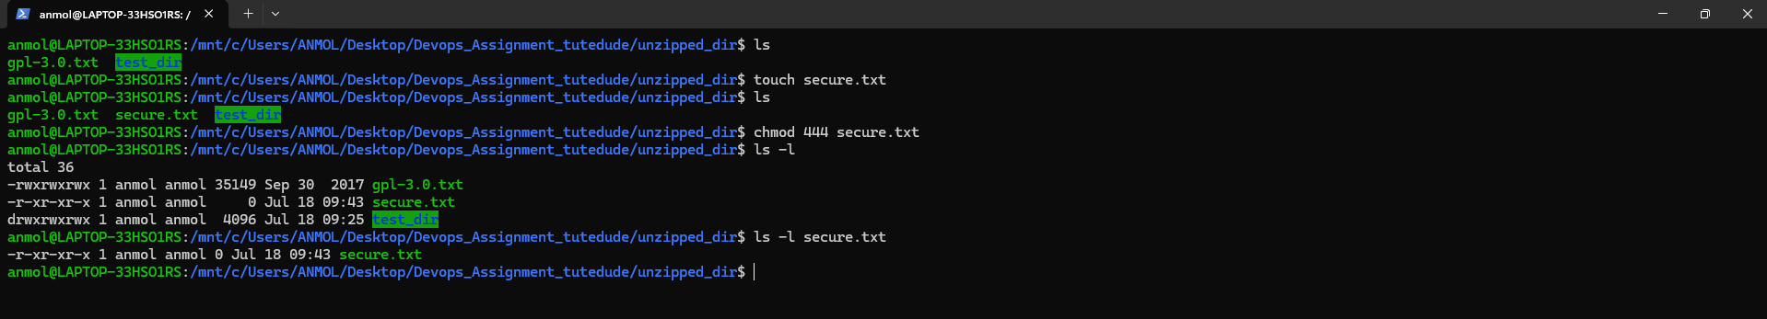
NOTE - All these three task 6.1, 6.2 , 6.3 (Screenshot is in same image only)

7. Working with Environment Variables

Task 7.1: Create an Environment Variable
Command:
export MY_VAR="Hello, Linux!"
Explanation:
The export command creates an environment variable that is available to the current shell session and any child processes. In this task, a variable named MY_VAR is created and assigned the value "Hello, Linux!".

Task 7.2: Display the Variable
Command:
echo $MY_VAR
Explanation:
The echo command displays text or the value stored in a variable. The $ symbol tells Linux to retrieve the value of the environment variable MY_VAR, which should display:
Hello, Linux!
NOTE - Both task 7.1, 7.2 (Screenshot is in same image only)

Conclusion
This assignment provided practical experience with fundamental Linux commands used for file and directory management, viewing and searching file contents, compressing and extracting files, downloading files from the internet, managing file permissions, and working with environment variables. These commands are essential for efficiently performing day-to-day tasks in a Linux operating system and form the foundation for system administration, software development, and DevOps practices.

GitHub Repository Link
Repository URL: https://github.com/Bruhhh78/TuteDude-Assignments

